


HSIR TIP SHEET
© This material contains confidential and copyrighted information of Epic Systems Corporation

Epic Version: 2022 | User(s) Affected: ECL Site Administrators
Application: EpicCare Link | Date in Effect: 2/3/2023
Topic: EpicCare Link (ECL) for Site Administrators

Description: EpicCare Link (ECL) Site Administrators are responsible for managing users at their facility. This tipsheet explains how to request new user accounts for existing users. If you have any difficulty, please contact the UTSW Help Desk at 214-648-7600 or ServiceDesk@UTSouthwestern.edu and specify that you are an EpicCare Link user.

URL: https://epiccarelink.utsouthwestern.edu
Browser Compatibility: The application can be accessed using the latest versions of Microsoft Edge, Firefox, or Chrome on the Windows operating system. Users of the Macintosh operating system can use the latest versions of Firefox, Chrome, or Safari to access the applications. EpicCare Link can also be accessed by Apple iPads using the Safari browser and Android tablets using the Chrome browser. The Chrome browser on iOS is not supported. To function properly with your web application, a browser must be able to accept cookies, and it must be able to run JavaScript.

Request New User Accounts
Follow the steps below to request access for new users or to request an adjustment to an existing user’s access.
- Click on the Admin tab from the top navigation toolbar.
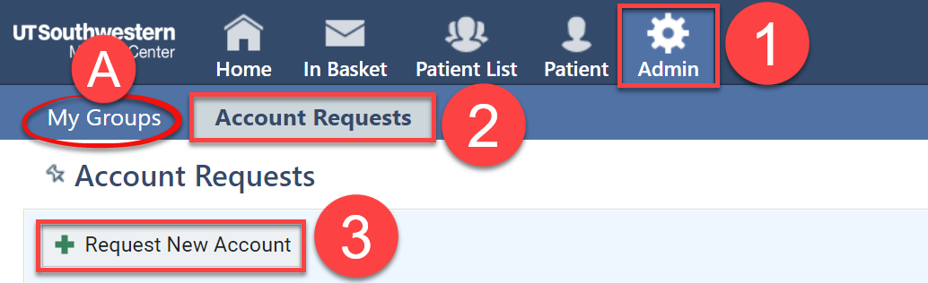
  - Be sure to check the My Groups section to confirm that this user does not already have access to your group. If the user is listed in the My Groups section, then you can provide them with their Login ID to login and/or reset their password if they don’t remember it.
- Click Account Requests.
- Click the Request New Account button.
- Choose what kind of user the account will be for (Provider, Clinical Staff, or Non-Clinician).
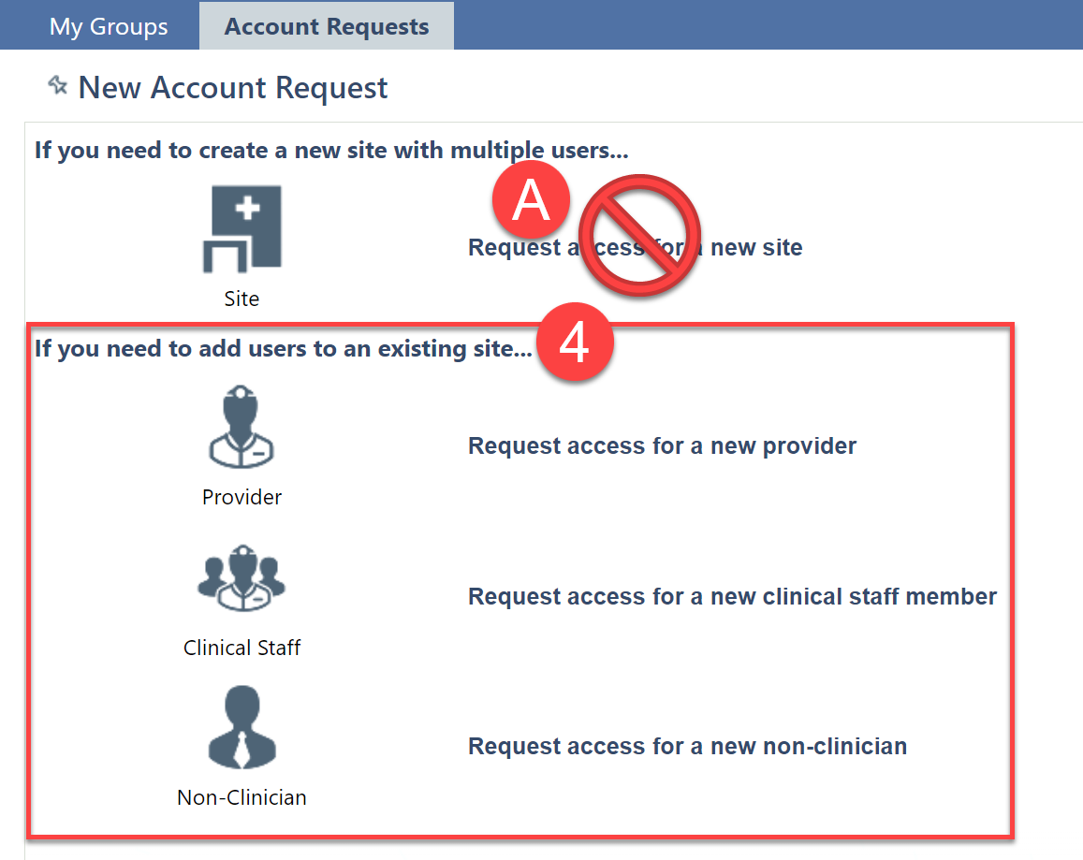
  - Please Note – requests to create a new site (facility or location) access should NOT be submitted through EpicCare Link. If a new site needs to be created, please submit a request online at https://utswmed.org/physician-resources/epiccare-link/ for each new location.
- Fill out the required fields that appear.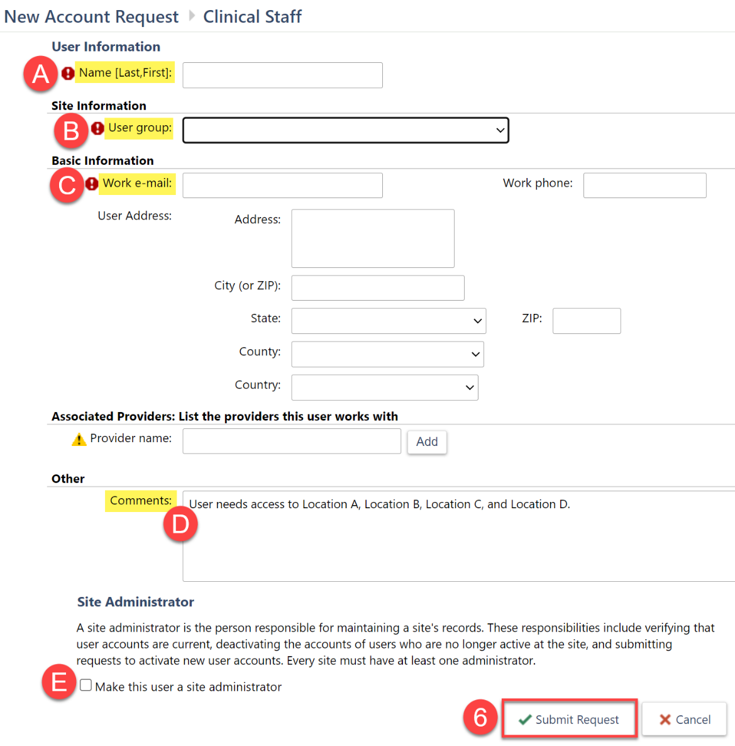
  - Name: enter the user’s name in the format Last Name, First Name.
  - User group: select the facility that this user should have access to. If the user needs access to multiple facilities, specify the appropriate facilities needed in the comments section.
  - Work e-mail: enter the user’s work email address.
  - Comments: enter any relevant comments regarding what access is needed. This could include a list of facilities the user should have access to or clarification that this request is to adjust the access of an existing user.
  - Site Administrator: check the “Make this user a site administrator” checkbox if the user should have additional Site Administrator access.
    - Please Note – each facility can have a maximum of 2 Site Administrators. So, if this user is meant to replace an existing Site Administrator, please specify this in the comments section.
- Click Submit Request.
- You will receive an email within 10 business days once the new user account is created so you can distribute the login instructions to the new user.

